Supplementary Bill
- The Bill will be generated ONLY when one DAILY BOOKING bill is generated.
- The DETAILS will be entered as a separate bill
- The Bill will be created for
- Electricity Charges
- Makeup Room
- Outdoor
- Bill Details will have charges, Rate, Amount. The Qty. will have break up in diff table.
- Separate Bills can be printed
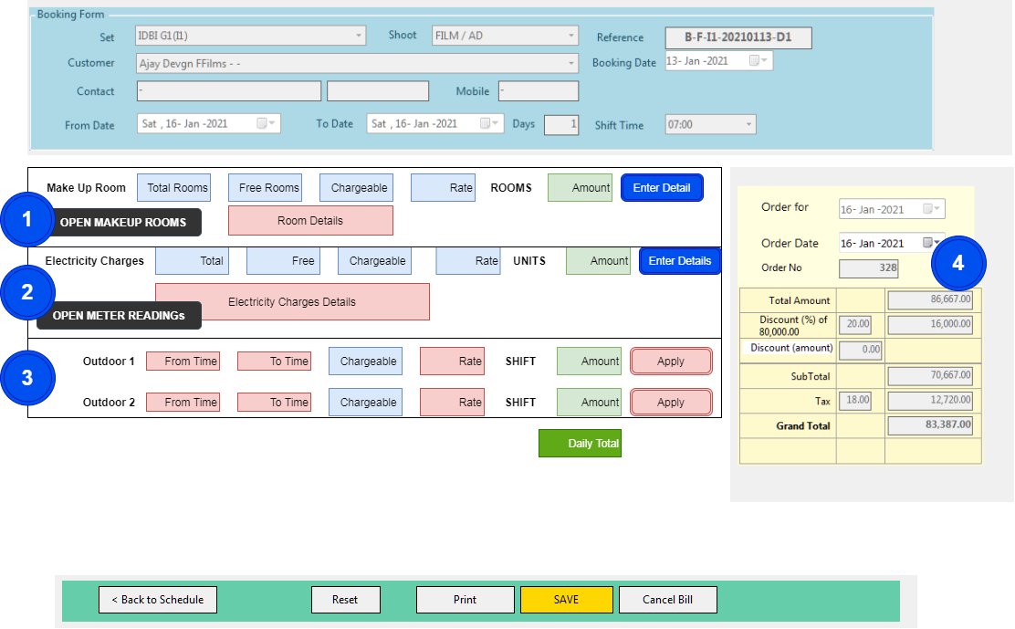
- Section 1: Makeup Room
  - By Default the Makeup Rooms from the selected SET will be shown
  - Additional Makeup Room from Other SET can be Added
  - From the list of Makeup Rooms, mark occupied rooms
  - The Total Makeup Rooms will be calculated
  - After completion of marking, click on CLOSE.
  - The Total makeup rooms, free makeup room will be shown
  - The charges of makeup room will be calculated
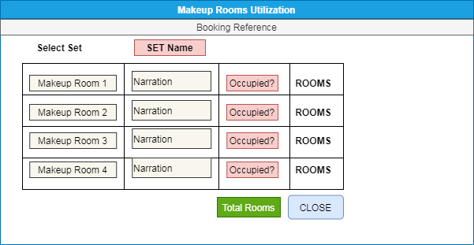

- Section 2: Electricity Charges
The METER Readings FORM will be opened. This FORM can be used for BILLING / FACILITY Activity.
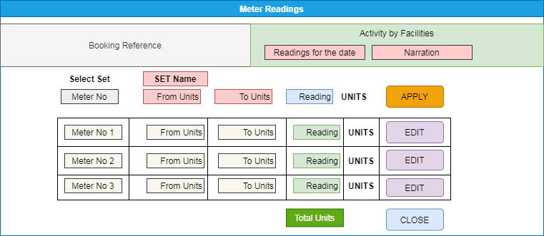
  - If the METER Readings are to be entered for Booking – The Booking Details will be shown
  - IF the METER Readings are to be entered for ACTIVITY of FACILITIES, the DETAILS will be entered.
  - Reading for the DATE will be entered.
  - The Meter No. of the SET will be selected.
  - In case of Booking – Meter of the SET will be selected. Additional Meter from other SET can be added.
  - FROM – TO units will be entered
  - The Total Units will be calculated.
  - Optional – Other Meter can be selected and UNITs details will be entered.
  - Total Units will be calculated. If FREE units are applicable will be applied to Total UNITs.
  - The Electricity charges will be calculated

- Section 3: Outdoor Entries (Optional)
  - In case of Outdoor shooting is carried out, the FROM – TO time will be entered.
  - Hours will be calculated
  - The RATE to calculate amount will be entered OR LUMPSUM Amount will be entered.
- Section 4: Bill Valuation
  - The Total Amount will be calculated.
  - DISCOUNTS will not be applicable
  - TAX will be applicable
  - BILL NO – This will be generated from the regular series

- SET-Electricity Meter and SET-Makeup Room Master
Entry of Set-wise Electricity Meter and Makeup Room.
  - The Set will be selected
  - Meter No 1, 2, 3,4 : Electricity Meter No will be entered
  - Alias: The conventional name / usage of the meter will be entered
  - Remarks: If any.
Makeup Rooms: The serial numbers of the makeup rooms will be generated and will be used in Billing
  - From No – To No: The makeup room numbers will be entered.
  - Generate – The series of Makeup Room numbers will be generated as per FROM and TO numbers
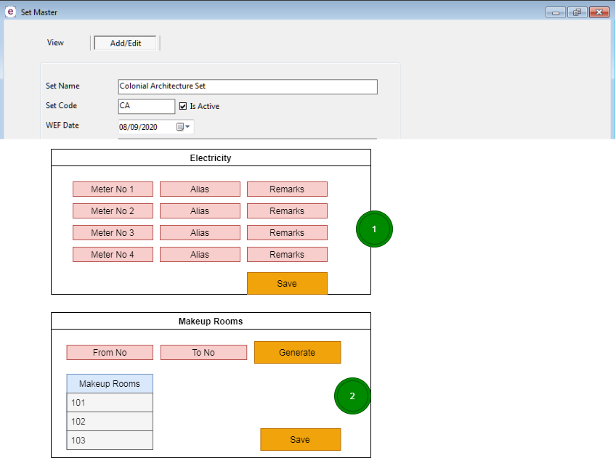

- Outdoor Set Master
  - The master will be created for the OUTDOOR. The Outdoor will be linked to the existing SET and independent.
  - The UoM for the billing will be entered.
  - The charges can be used in ENQUIRY form entry.
  - The charges can be used during the Bill Entry.

DB IMPACT
- MASTER
  - SET-Electricity Meter
  - SET-MakeUp Room Master
  - Outdoor Set Master
- TRANSACTION
  - Booking-MakeUpRoom Utilisation (Booking-SupplementaryBill-DETAILS)
  - Booking-ElectricityMeter (Booking-SupplementaryBill-DETAILS)
  - Booking-Outdoor (Booking-SupplementaryBill-DETAILS)
  - Booking-SupplementaryBill-MASTER
  - Booking-SupplementaryBill-DETAILS
- UI
  - Electricity Meter
  - Makeup Room Master
  - Outdoor set Master
  - Booking – Supplementary Bill
  - Booking – Makeup Room Utilization
  - Booking – Electricity Meter Readings
  - Booking – Outdoor
  - Print Supplementary Bill
  - Electricity Meter Readings for FACILITIES
- REPORTS
  - Makeup Room Utilisation
  - Electricity Meter Readings
  - Supplementary Bills

Accounting
Debtor Report
- To maintain TDS deposited by customers. Balance of Customers and marking settlement of Booking.
- BATCH is created from multiple Bills of CUSTOMER from the System.
- The batch will be marked with TDS and Receipts.
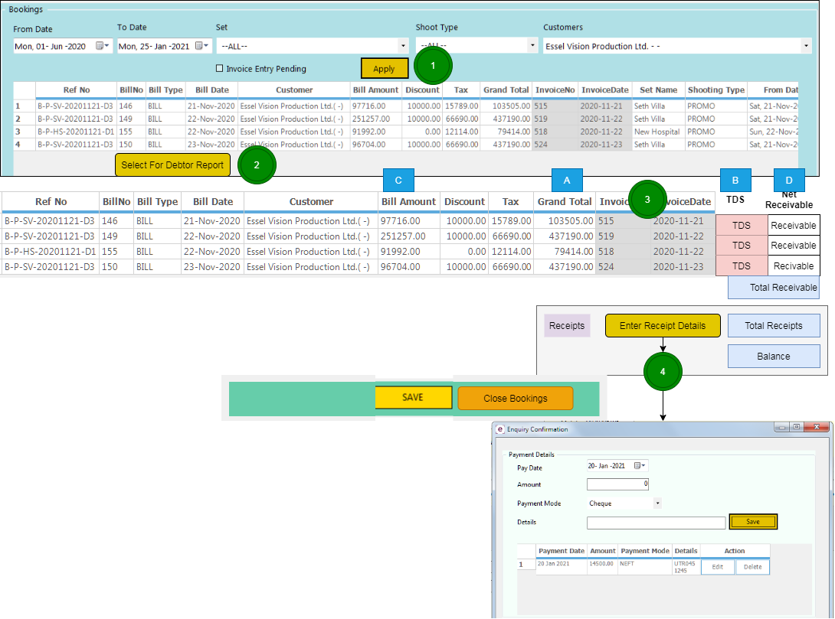
- The Receipts will be entered against Bookings
- The open BATCH will be shown for Receipts
- The BATCH will be closed by the user after entry of all the Receipts of customer.
- The Total amount of receipts can be MORE THAN Total Receivable (Excess received from the customer) or LESS THAN Total Receivable (balance with the customer)
- Reports – Customer wise Balance Report will be generated
- Customer Selection
  - All the Bookings not settled will be selected
- Booking Selection
  - Booking Schedule will be selected
  - A batch will be created for Booking Settlement
- TDS Entry
  - TDS amount will be entered for each booking
  - Total of Receivable will be generated
- Receipts Entry
  - The details of Receipts will be entered
  - The Advance received for the booking will be selected from the Enquiry ENTRY
  - Total receipts will be calculated
  - Balance Payable will be selected
- Save / Confirm Payment
  - The PARTIAL settlement can be saved.
  - The Partial settlement can be selected further for Complete Settlement
  - CONFIRM – to complete settlement

DB IMPACT
- MASTER
- TRANSACTIONS
  - SETTLEMENT MASTER
  - SETTLEMENT BATCH DAILY BILLS
  - SETTLEMENT RECEIPTS

